**Meyers research Logical rules document**

**Template Check**:

Script Taken the Header and will check whether all the attributes Available or not**.**

**URL Format Check**:

Using **Validators Module** to check URL format Ex: (<https://www.xxxxxxxxx.com>),(https://www.xxxxxxxxx.net) **Note:** It will not find 404 pages

**Special Characters:**

It will check the special character symbols- is available on mentioned text file “special_characters.txt file ” globally, whether it is available or not. **Note:** In a record if there is any special characters present in the individual cell then it will displaying as an Error then you have to cross check the cells from the beginning of Error Record.

**Phone Number:**

Remove all symbols like “Hyphen [-]“ , “Open and close bracket()” ,”Pipe symbol[|]",”Dot Symbol[.]” and “Plus [+]” which is available in the phone field and check the numeric values appears if it is not available it will considered as Error **Note:** The Number length will be cross check through the Script ,The length of the Number Should be followed as 10 or Else It as the following script will be Error and Same phone number be repeated twice or thrice in a cell for a particular record then Script will considered as Error.

**Latitude:**

Remove the symbol “Dot (.)” in this field and check whether the numeric values are appears if not it will considered as Error.

**Note:** Script will removes only “Dot symbol (.)”if there is any Irreverent Symbol appears script considered as Error and Script check latitude values must in Positive Number.

**Longitude:**

Remove the symbol “Dot (.) and Hyphen (-) ” in this field and check whether the numeric values are appears if not it will considered as Error.

**Note:** Script will removes “Dot (.) and Hyphen (-) and if there is any Irreverent Symbols appears script considered as Error Script check Longitude values must in Negative Number.

**Project_Status:**

I have referred to the old files and collected the project status data. Therefore I have placed those data in a script. Script will cross check the project status data and it will be depending whether Error or not.

|  |
| --- |
| **Script Input status data:**  status_list=['Sold Out', 'Now Open', 'Final Opportunity', 'Coming Soon', 'Now Selling', 'Limited Availability', 'CLOSE OUT','COMING Summer 2022','COMING Spring 2022','Phase 2 Coming Soon!', 'Homes coming soon!', 'Almost Sold Out', |
| 'New Phase! Limited Release!', 'Coming Fall of 2022!','Model Open, Now Selling!', 'Active', 'Model Now Open!', 'Final Phase Coming Soon', 'Next Phase Coming Soon', 'New Phase Available', 'Coming 2023','NOW SELLING PHASE 3!', |
| 'Model Grand Opening!' ,'Final Homes Remaining ,'closeout' ,'Models Coming Soon' ,'SOLD OUT!' ,'Selling out', 'final phase now open', 'Almost Sold Out', 'Model for Sale', 'Now Pre-Selling', 'New Model Now Open', 'New Phase Coming Soon', |
| 'CLOSE OUT','NOW SELLING!','NOW SELLING','COMING SOON','MODEL GRAND OPENING','GRAND OPENING','COMING SOON!','NOW OPEN!','NOW OPEN', 'Now Open!', 'Closeout!', 'Coming Soon!', 'Grand opening!', 'NOW SELLING', 'Final Phase Coming!', 'NEW PHASE COMING', |
| 'FINAL OPPORTUNITIES','NEW PHASE COMING', 'Sold Out!', 'Now Selling!', 'NOW PRE-SELLING!', 'New Section Coming Soon!', 'Model Home Now Open', 'New Phase Now Open', 'New Section Now Open!', 'Temporarily Sold Out', 'New Models Now Open!', 'Now Selling Final Phase!', |
| 'FINAL OPPORTUNITIES!!!','COMING SOON!!!','COMING SOON!!!','COMING SOON!!!','COMING SOON!!!','NOW SELLING!!!!','CURRENTLY SOLD OUT - NEW PHASE COMING','GRAND OPENING!!!','NOW SELLING PHASE 3!!!','NEW PHASE COMING!!!','NEW PHASE COMING SOON!!! NOW PRE-SELLING!!!', |
| 'NOW PRE-SELLING','NOW PRESELLING','FINAL OPPORTUNITIES REMAINING','MODEL NOW OPEN','SELLING FAST','PHASE TWO NOW SELLING','MODEL NOW OPEN','FINAL HOMES','SOLD OUT','NOW SELLING PHASE II','NEW PHASE COMING SOON','FINAL HOME','Coming Soon ','Final Opportunities!', |
| 'New Phase - Now Selling!', 'Quick-Move Homes Available Now!', 'Limited Availability', 'Now selling', Grand Opening!', 'Final Opportunities!', 'Final Opportunities', 'Model now open', 'Grand Opening', 'Final Opportunities!', 'coming soon!'] |

**Project_Address:**

Script Using a Regex Module for Project Address, Script takes address data and it will compare the given pattern whether It will be a pattern format or not. Hence it is not in pattern format script considered as error.

**Pattern** = ^(\\d{1,}) [a-zA-Z0-9\\s]+(\\,)? [a-zA-Z]+(\\,)? [A-Z]{2} [0-9]{5}$

**Note:** Script will check the length of Zip must in 5

**Duplicate check:**

Script will check the duplicate based on Records.

**Rules:**

* Output File Must in Excel format.
* Excel Sheet1 Must in Scraped_Output
* Once Script running we don’t open file until script end.
* Script output shows in Input file.

**Input:**

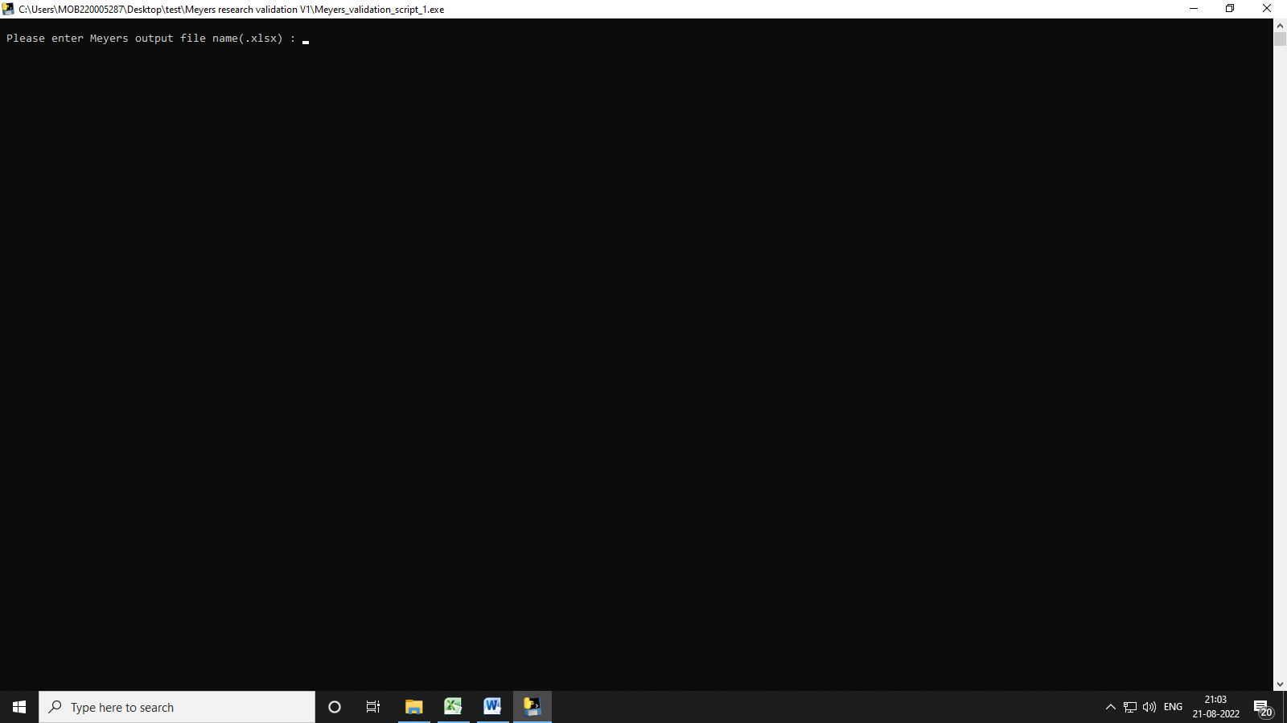

**Output Screenshot:**

